CHAPTER 10

HYPOTHESIS TESTING

MULTIPLE CHOICE QUESTIONS

In the following multiple-choice questions, please circle the correct answer.

- If a researcher takes a large enough sample, he/she will almost always obtain:

- virtually significant results
- practically significant results
- consequentially significant results
- statistically significant results
ANSWER: d

- The null and alternative hypotheses divide all possibilities into:

- two sets that overlap
- two non-overlapping sets
- two sets that may or may not overlap
- as many sets as necessary to cover all possibilities
ANSWER: b

- Which of the following is true of the null and alternative hypotheses?

- Exactly one hypothesis must be true
- both hypotheses must be true
- It is possible for both hypotheses to be true
- It is possible for neither hypothesis to be true
ANSWER: a

- One-tailed alternatives are phrased in terms of:

- ≠
- < or >
- ≈ or =
- 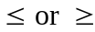
ANSWER: b

- The chi-square goodness-of-fit test can be used to test for:

- significance of sample statistics
- difference between population means
- normality
- probability
ANSWER: c

- A type II error occurs when:

- the null hypothesis is incorrectly accepted when it is false
- the null hypothesis is incorrectly rejected when it is true
- the sample mean differs from the population mean
- the test is biased
ANSWER: a

- Of type I and type II error, which is traditionally regarded as more serious?

- Type I
- Type II
- They are equally serious
- Neither is serious
ANSWER: a

- You conduct a hypothesis test and you observe values for the sample mean and sample standard deviation when n = 25 that do not lead to the rejection of . You calculate a p-value of 0.0667. What will happen to the p-value if you observe the same sample mean and standard deviation for a sample > 25?

- Increase
- Decrease
- Stay the same
- May either increase or decrease
ANSWER: b

- The form of the alternative hypothesis can be:

- one-tailed
- two-tailed
- neither one nor two-tailed
- one or two-tailed
ANSWER: d

- A two-tailed test is one where:

- results in only one direction can lead to rejection of the null hypothesis
- negative sample means lead to rejection of the null hypothesis
- results in either of two directions can lead to rejection of the null hypothesis
- no results lead to the rejection of the null hypothesis
ANSWER: c

- The value set for is known as:

- the rejection level
- the acceptance level
- the significance level
- the error in the hypothesis test
ANSWER: c

- A study in which randomly selected groups are observed and the results are analyzed without explicitly controlling for other factors is called:

- an observational study
- a controlled study
- a field test
- a simple study
ANSWER: a

- The null hypothesis usually represents:

- the theory the researcher would like to prove.
- the preconceived ideas of the researcher
- the perceptions of the sample population
- the status quo
ANSWER: d

- The ANOVA test is based on which assumptions?

- the sample are randomly selected
- the population variances are all equal to some common variance
- the populations are normally distributed
- the populations are statistically significant

- All of the above
- II and III only
- I, II, and III only
- I, and III only
ANSWER: b

- In statistical analysis, the burden of proof lies traditionally with:

- the alternative hypothesis
- the null hypothesis
- the analyst
- the facts
ANSWER: a

- When one refers to “how significant” the sample evidence is, he/she is referring to the:

- value of
- the importance of the sample
- the p-value
- the F-ratio
ANSWER: c

- Which of the following values is not typically used for ?

- 0.01
- 0.05
- 0.10
- 0.25
ANSWER: d

- Smaller p-values indicate more evidence in support of:

- the null hypothesis
- the alternative hypothesis
- the quality of the researcher
- further testing
ANSWER: b

- The chi-square test can be too sensitive if the sample is:

- very small
- very large
- homogeneous
- predictable
ANSWER: b

- The hypothesis that an analyst is trying to prove is called the:

- elective hypothesis
- alternative hypothesis
- optional hypothesis
- null hypothesis
ANSWER: b

- A p-value is considered “convincing” if it is:

- less than 0.01
- between 0.01 and 0.05
- 0.05 and 0.10
- greater than 0.10
ANSWER: a

- One-way ANOVA is used when:

- analyzing the difference between more than two population means
- analyzing the results of a two-tailed test
- analyzing the results from a large sample
- analyzing the difference between two population means
ANSWER: a

- A null hypothesis can only be rejected at the 5% significance level if and only if:

- a 95% confidence interval includes the hypothesized value of the parameter
- a 95% confidence interval does not include the hypothesized value of the parameter
- the null hypothesis is void
- the null hypotheses includes sampling error
ANSWER: b

- Typically one-way ANOVA is used in which of the following situations?

- there are several distinct populations
- there are two sample populations over 4000
- randomized experiments
- randomly selected populations

- All of the above
- II and III only
- I, II, and III only
- I, and III only
ANSWER: d

- The chi-square test is not very effective if the sample is:

- small
- large
- irregular
- heterogeneous
ANSWER: a

- The alternative hypothesis is also known as the:

- elective hypothesis
- optional hypothesis
- research hypothesis
- null hypothesis
ANSWER: c

- An informal test for normality that utilizes a scatterplot and looks for clustering around a 45° line is known as:

- a Lilliefors test
- an empirical cdf
- a p-test
- a quantile-quantile plot
ANSWER: d

- Which of the following tests are used to test for normality?

- A t-test and an ANOVA test
- An Empirical CDF test and an F-test
- A Chi-Square test and a Lilliefors test
- A Quantile-Quantile plot and a p-value test
ANSWER: c

- If a teacher is trying to prove that new method of teaching math is more effective than traditional one, he/she will conduct a:

- one-tailed test
- two-tailed test
- point estimate of the population parameter
- confidence interval
ANSWER: a

- A type I error occurs when:

- the null hypothesis is incorrectly accepted when it is false
- the null hypothesis is incorrectly rejected when it is true
- the sample mean differs from the population mean
- the test is biased
ANSWER: b

TEST QUESTIONS

31. A sport preference poll yielded the following data for men and women. Use the 5% significance level and test to determine is sport preference and gender are independent.

 |  | Sport Preference
 |  | Basketball | Football | Soccer
 | Men | 20 | 25 | 30 | 75

Gender
 | Women | 18 | 12 | 15 | 45
 |  | 38 | 37 | 45 | 120

ANSWER:
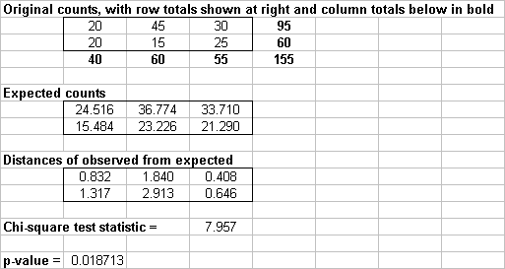

We reject the null hypothesis of independence at the 5% significance level (since p-value = 0.019 < 0.05). We may conclude that sport preference and gender are not independent; that is, there is evidence that sport preference of men is different from that of women.

32. Suppose that we observe a random sample of size n from a normally distributed population. If we are able to reject 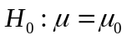 in favor of 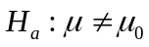 at the 5% significance level, is it true that we can definitely reject in favor of the appropriate one-tailed alternative at the 2.5% significance level? Why or why not?

ANSWER:
This is not true for certain. Suppose 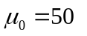and the sample mean we observe is 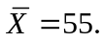 If the alternative for the one-tailed test is 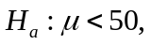 then we obviously can’t reject the null because the observed sample mean  is in the wrong direction. But if the alternative is 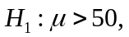 we can reject the null at the 2.5% level. The reason is that we know the p-value for the two-tailed test was less than 0.05. The p-value for a one-tailed test is half of this, or less than 0.025, which implies rejection at the 2.5% level.

33. An investor wants to compare the risks associated with two different stocks. One way to measure the risk of a given stock is to measure the variation in the stock’s daily price changes. The investor obtains a random sample of 20 daily price changes for stock 1 and 20 daily price changes for stock 2. These data are shown in the table below. Show how this investor can compare the risks associated with the two stocks by testing the null hypothesis that the variances of the stocks are equal. Use = 0.10 and interpret the results of the statistical test.

Day | Price Change  for stock 1 | Price Change for stock 2
1 | 1.86 | 0.87
2 | 1.80 | 1.33
3 | 1.03 | -0.27
4 | 0.16 | -0.20
5 | -0.73 | 0.25
6 | 0.90 | 0.00
7 | 0.09 | 0.09
8 | 0.19 | -0.71
9 | -0.42 | -0.33
10 | 0.56 | 0.12
11 | 1.24 | 0.43
12 | -1.16 | -0.23
13 | 0.37 | 0.70
14 | -0.52 | -0.24
15 | -0.09 | -0.59
16 | 1.07 | 0.24
17 | -0.88 | 0.66
18 | 0.44 | -0.54
19 | -0.21 | 0.55
20 | 0.84 | 0.08

ANSWER:
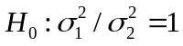
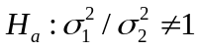
Test statistic: 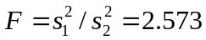
P-value=0.023
Since the P-values is less than 0.10, we reject the null hypothesis of equal variances and conclude that the variances of the stocks are not equal at the 10% level.

QUESTIONS 34 THROUGH 37 ARE BASED ON THE FOLLOWING INFORMATION:

BatCo (The Battery Company) produces your typical consumer battery. The company claims that their batteries last at least 100 hours, on average. Your experience with the BatCo battery has been somewhat different, so you decide to conduct a test to see if the companies claim is true. You believe that the mean life is actually less than the 100 hours BatCo claims. You decide to collect data on the average battery life (in hours) of a random sample and the information related to the hypothesis test is presented below.

Test of 100 versus one-tailed alternative
Hypothesized mean | 100.0
Sample mean | 98.5
Std error of mean | 0.777
Degrees of freedom | 19
t-test statistic | -1.932
p-value | 0.034

34. Can the sample size be determined from the information above? Yes or no? If yes, what is the sample size in this case?

ANSWER:
Yes. 19 + 1 = 20.

35. You believe that the mean life is actually less than 100 hours, should you conduct a one-tailed or a two-tailed hypothesis test? Explain your answer.

ANSWER:
One-tailed test. You are interested in the mean being less than 100.

36. What is the sample mean of this data? If you use a 5% significance level, would you conclude that the mean life of the batteries is typically more than 100 hours? Explain your answer.

ANSWER:
98.5 hours. No. You would reject the null hypothesis in favor of the alternative, which is less than 100 hours (0.034 < 0.05).

37. If you were to use a 1% significance level in this case, would you conclude that the mean life of the batteries is typically more than 100 hours? Explain your answer.

ANSWER:
Yes. You cannot reject the null hypothesis at a 1% level of significance (0.034 > 0.01).

QUESTIONS 38 AND 39 ARE BASED ON THE FOLLOWING INFORMATION:

Two teams of workers assemble automobile engines at a manufacturing plant in Michigan. A random sample of 145 assemblies from team 1 shows 15 unacceptable assemblies. A similar random sample of 125 assemblies from team 2 shows 8 unacceptable assemblies.

38. Construct a 90% confidence interval for the difference between the proportions of unacceptable assemblies generated by the two teams.

ANSWER:

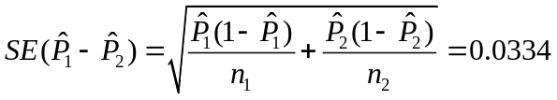

Lower limit = -0.0155, and Upper limit = 0.0943

39. Based on the confidence interval constructed in Question 38, is there sufficient evidence o conclude, at the 10% significance level, that the two teams differ with respect to their proportions of unacceptable assemblies?

ANSWER:
Because the 90% confidence interval includes the value 0, we cannot reject the null hypothesis of equal proportions.

40. Staples, a chain of large office supply stores, sells a line of desktop and laptop computers. Company executives want to know whether the demands for these two types of computers are related in any way. Each day's demand for each type of computers is categorized as Low, Medium-Low, Medium-High, or High. The data shown in the table below is based on 200 days of operation. Based on these data, can Staples conclude that demands for these two types of computers are independent? Test at the 5% level of significance.

 |  |  | Desktops
 |  | Low | Med-Low | Med-High | High
 | Low | 3 | 14 | 14 | 4 | 35
Laptops | Med-Low | 6 | 18 | 17 | 22 | 63
 | Med-High | 13 | 16 | 11 | 16 | 56
 | High | 8 | 14 | 15 | 9 | 46
 |  | 30 | 62 | 57 | 51 | 200

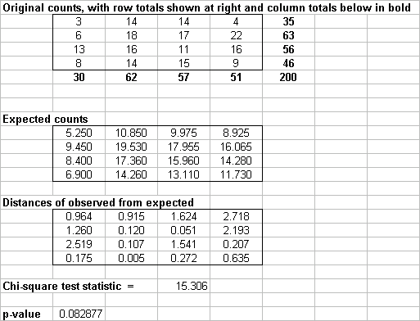
ANSWER:

We fail to reject the null hypothesis of independence at the 5% significance level (since p-value = 0.083 > 0.05). We may conclude that demands for these two types of computers are independent

41. Suppose that you are asked to test 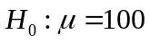 versus 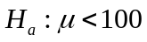 at the = 0.05 significance level. Furthermore, suppose that you observe values of the sample mean and sample standard deviation when n = 50 that lead to the rejection of . Is it true that you might fail to reject if you were to observe the same values of the sample mean and standard deviation from a sample with n > 50? Why or why not?

ANSWER:
No. When n increases and the standard deviation of the sample mean stays the same, the standard error will decrease. Therefore, the test statistic will become more significant. If you rejected 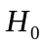 with n = 50, you will continue to reject with n > 50.

QUESTIONS 42 THROUGH 44 ARE BASED ON THE FOLLOWING INFORMATION:

Do graduates of undergraduate business programs with different majors tend to earn disparate starting salaries? Below you will find the StatPro output for 32 randomly selected graduate with majors in accounting (Acct), marketing (Mktg), finance (Fin), and information systems (IS).

Summary statistics for samples
 | Acct. | Mktg. |  |  | Fin. |  |  | IS
Sample sizes | 9 | 6 |  |  | 10 |  |  | 7
Sample means | 32711.67 | 27837.5 |  |  | 30174 |  |  | 32869.3
Sample standard deviations | 2957.438 | 754.982 |  |  | 1354.613 |  |  | 3143.906
Sample variances | 8746437.5 | 569997.5 |  |  | 1834976.7 |  |  | 9884145.2
Weights for pooled variance | 0.286 | 0.179 |  |  | 0.321 |  |  | 0.214
Number of samples | 4
Total sample size | 32
Grand mean | 31039.22
Pooled variance | 5308612.5
Pooled standard deviation | 2304.043

One Way ANOVA table
Source | SS | df | MS |  |  | F |  |  | p-value
Between variation | 117609807 | 3 | 39203269 |  |  | 7.385 |  |  | 0.0009
Within variation | 148641149 | 28 | 5308612
Total variation | 266250955 | 31

Confidence Intervals for Differences
Difference | Mean diff | Lower limit | Upper limit
Acct. - Mktg. | 4874.167 | 1263.672 | 8484.661
Acct. – Fin. | 2537.667 | -609.890 | 5685.223
Acct. - IS | -157.619 | -3609.912 | 3294.674
Mktg. – Fin. | -2336.500 | -5874.048 | 1201.048
Mktg. - IS | -5031.786 | -8843.014 | -1220.557
Fin. - IS | -2695.286 | -6071.216 | 680.644

42. Assuming that the variances of the four underlying populations are equal, can you reject at a 5% significance level that the mean starting salary for each of the given business majors? Explain why or why not?

ANSWER:
Yes. Because of the F-test and the p-value is less than 0.05 (p-value = 0.0009)

43. Is there any reason to doubt the equal-variance assumption made in Question 42? Support your answer.

ANSWER:
Yes, there is some cause for concern. The F-test is rather robust, however, is this case, the sample sizes are rather small and of different sizes.

44. Use the information above related to the 95% confidence intervals for each pair of differences to explain which ones are statistically significant at α = 0.05.

ANSWER:
These confidence intervals show that the accounting majors stating salaries, on average, are larger than the marketing majors. There is not a significant difference for the other pairs using a 95% confidence interval.

QUESTIONS 45 THROUGH 47 ARE BASED ON THE FOLLOWING INFORMATION:

Do graduates of undergraduate business programs with different majors tend to earn disparate average starting salaries? Consider the data given in the table below.

Accounting | Marketing | Finance | Management
$37,220 | $28,620 | $29,870 | $28,600
$30,950 | $27,750 | $31,700 | $27,450
$32,630 | $27,650 | $31,740 | $26,410
$31,350 | $27,640 | $32,750 | $27,340
$29,410 | $28,340 | $30,550 | $27,300
$37,330 |  | $29,250
$35,700 |  | $28,890
 |  | $30,150

45. Is there any reason to doubt the equal-variance assumption made in the one- way ANOVA model in this particular case? Explain.

ANSWER:

Summary measures table
 | Accounting | Marketing | Finance | Management
Sample sizes | 7 | 5 | 8 | 5
Sample means | 33512.857 | 28000.000 | 30612.500 | 27420.000
Sample standard deviations | 3213.413 | 451.276 | 1342.458 | 780.096
Sample variances | 10326023.810 | 203650.000 | 1802192.857 | 608550.000
Weights for pooled variance | 0.286 | 0.190 | 0.333 | 0.190

There certainly is reason to doubt equal variances. The ratio of the largest standard deviation to the smallest is about 7.12, so the ratio of corresponding variances is about 51.

46. Assuming that the variances of the four underlying populations are indeed equal, can you reject at the 10% significance level that the mean starting salary is the same for each of the given business majors? Explain why or why not.

ANSWER:

One Way ANOVA table

Source of variation | SS | df | MS | F | p-value
Between groups | 140927283.143 | 3 | 46975761.048 | 12.677 | 0.0001
Within groups | 77820292.857 | 21 | 3705728.231
Total variation | 218747576.000 | 24

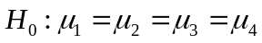
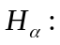 At least two population means are unequal.
The ANOVA table indicates definite mean difference, even at the 1% level (since the p-value is less than .01). Even if the test is not perfectly valid (because of unequal variances), we can still be pretty confident that the means are not all equal.

47. Generate 90% confidence intervals for all pairs of differences between means. Which of the differences, if any, are statistically significant at the 10% significance level?

ANSWER:
Simultaneous confidence intervals for mean differences with confidence level of 90%

 | Difference | Mean difference | Lower limit | Upper limit | Significant?
 | Accounting - Marketing | 5512.857 | 2510.523 | 8515.191 | Yes
 | Accounting - Finance | 2900.357 | 246.644 | 5554.071 | Yes
 | Accounting - Management | 6092.857 | 3090.523 | 9095.191 | Yes
 | Marketing - Finance | -2612.500 | -5535.603 | 310.603 | No
 | Marketing - Management | 580.000 | -2662.892 | 3822.892 | No
 | Finance - Management | 3192.500 | 269.397 | 6115.603 | Yes

The a

Accounting mean is significantly different (larger) than each of the others. Also, the Finance mean is significantly different (larger) than the Management mean. The other means are not significantly different from each other.

QUESTIONS 48 THROUGH 52 ARE BASED ON THE FOLLOWING INFORMATION:

Q-Mart is interested in comparing its male and female customers. Q-Mart would like to know if its female charge customers spend more money, on average, than its male charge customers. They have collected random samples of 25 female customers and 22 male customers. On average, women charge customers spend $102.23 and men charge customers spend $86.46. Additional information are shown below:

Summary statistics for two samples
 | Sales (Female) |  |  |  | Sales (Male)
Sample sizes | 25 |  |  | 22
Sample means | 102.23 |  |  | 86.460
Sample standard deviations | 93.393 |  |  | 59.695
Test of difference=0
Sample mean difference |  | 15.77
Pooled standard deviation |  | 79.466
Std error of difference |  | 23.23
t-test statistic |  | 0.679
p-value |  | 0.501

48. Given the information above, what is and 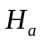 for this comparison? Also, does this represent a one-tailed or a two-tailed test? Explain your answer.

ANSWER:
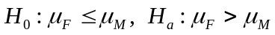. This represents a one-tail test.
49. What are the degrees of freedom for the t-statistic in this calculation? Explain how you would calculate the degrees of freedom in this case.

ANSWER:
d.f = 25 + 22 – 2 = 45

50. What is the assumption in this case that allows you to use the pooled standard deviation for this confidence interval?

ANSWER:
The assumption is that the populations’ standard deviations are equal (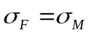).

51. Using a 10% level of significance, is there sufficient evidence for Q-Mart to conclude that women charge customers on average spend more than men charge customers? Explain your answer.

ANSWER:
No. There is not a statistical difference between women and men spending at Q-Mart, since p-value = 0.501 > 0.10.

52. Using a 1% level of significance, is there sufficient evidence for Q-Mart to conclude that women charge customers on average spend more than men charge customers? Explain your answer.

ANSWER:
No. There is not a statistical difference between women and men spending at Q-Mart, since p-value = 0.501 > 0.01.

53. The CEO of a software company is committed to expanding the proportion of highly qualified women in the organization’s staff of salespersons. He claims that the proportion of women in similar sales positions across the country in 1999 is less than 45%. Hoping to find support for his claim, he directs his assistant to collect a random sample of salespersons employed by his company, which is thought to be representative of sales staffs of competing organizations in the industry. The collected random sample of size 50 showed that only 18 were women. Test this CEO’s claim at the =.05 significance level and report the p-value. Do you find statistical support for his hypothesis that the proportion of women in similar sales positions across the country is less than 40%?

ANSWER:
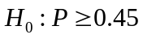
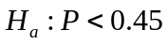
Test statistic: Z =-1.279
P-value = 0.10
There is not enough evidence to support this claim. The P-value is large (0.10).

QUESTIONS 54 THROUGH 56 ARE BASED ON THE FOLLOWING INFORMATION:

Joe owns a sandwich shop near a large university. He wants to know if he is servings approximately the same number of customers as his competition. His closest competitors are Bob and Ted. Joe decides to use a couple of college students to collect some data for him on the number of lunch customers served by each sandwich shop during a weekday. The data for two weeks (10 days) and additional information are shown below (the tables have been generated using StatPro).

Summary stats for samples
 |  | Joe’s |  | Bob’s |  |  | Ted’s
Sample sizes |  | 10 |  | 10 |  |  | 10
Sample means |  | 50.700 |  | 46.200 |  |  | 43.500
Sample standard deviations |  | 4.244 |  | 4.492 |  |  | 3.598
Sample variances |  | 18.011 |  | 20.178 |  |  | 12.944
Weights for pooled variance |  | 0.333 |  | 0.333 |  |  | 0.333
Number of samples |  | 3
Total sample size |  | 30
Grand mean |  | 46.800
Pooled variance |  | 17.044
Pooled standard deviation |  | 4.128

One-way ANOVA Table
Source | SS | df |  |  | MS |  |  | F |  |  |  | p-value
Between variation | 264.60 | 2 |  |  | 132.30 |  |  | 7.762 |  |  |  | 0.0022
Within variation | 460.20 | 27 |  |  | 17.044
Total variation | 724.80 | 29

Confidence Intervals for mean difference using 95% confidence level
Difference | Mean diff | Lower | Upper
Joe’s – Bob’s | 4.500 | -0.282 | 9.282
Joe’s – Ted’s | 7.200 | 2.418 | 11.982
Bob’s – Ted’s | 2.700 | -2.082 | 7.482

54. Are all three sandwich shops serving the same number of customers, on average, for lunch each weekday? Explain how you arrived at your answer.

ANSWER:
No. You should reject H_{o} at a 5% significance level (p-value = 0.0022). Means are not all equal.

55. Explain why the weights for the pooled variance are the same for each of the samples.

ANSWER:
The weights for the pooled variance are the same for each of the samples, because sample sizes are equal (sample of 10 customers from each sandwich shop).

56. Use the information related to the 95% confidence interval to explain how the number of customers Joe has each weekday compares to his competition.

ANSWER:
These intervals show that there is not a significant difference between Joe’s and Bob’s. However, there is a significant difference between Joe’s and Ted’s using a 95% confidence interval.

QUESTIONS 57 AND 58 ARE BASED ON THE FOLLOWING INFORMATION:

The manager of a consulting firm in Lansing, Michigan, is trying to assess the effectiveness of computer skills training given to all new entry-level professionals. In an effort to make such an assessment, he administers a computer skills test immediately before and after the training program to each of 20 randomly chosen employees. The pre-training and post-training scores of these 20 individuals are shown in the table below.

Employee | Score before | Score after
1 | 62 | 77
2 | 63 | 77
3 | 74 | 83
4 | 64 | 88
5 | 84 | 80
6 | 81 | 80
7 | 54 | 83
8 | 61 | 88
9 | 81 | 80
10 | 86 | 88
11 | 75 | 93
12 | 71 | 78
13 | 86 | 82
14 | 74 | 84
15 | 65 | 86
16 | 90 | 89
17 | 72 | 81
18 | 71 | 90
19 | 85 | 86
20 | 66 | 92

57. Using a 10% level of significance, do the given sample data support that the firm’s training programs is effective in increasing the new employee’s working knowledge of computing?

ANSWER:
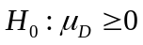
Test statistic: t = - 4.471 (paired t-test)
P-value = 0.00013
The test scores have improved by an average of 11 points. Since the P-value is virtually 0, there is enough evidence to conclude that the given sample data support that the firm’s training program is increasing the new employee’s knowledge of computing at the 10% significance level.

58. Re-do Question 57 using a 1% level of significance.

ANSWER:
Again, since the P-value is virtually zero, there is plenty of evidence to support the effectiveness of the program at the 1% level of significance.

QUESTIONS 59 THROUGH 62 ARE BASED ON THE FOLLOWING INFORMATION:

Suppose a firm that produces light bulbs wants to know whether it can claim that it light bulbs typically last more than 1500 hours. Hoping to find support for their claim, the firm collects a random sample and records the lifetime (in hours) of each bulb. The information related to the hypothesis test is presented below.

Test of 1500 versus one-tailed alternative
Hypothesized mean | 1500.0
Sample mean | 1509.5
Std error of mean | 4.854
Degrees of freedom | 24
t-test statistic | 1.953
p-value | 0.031

59. Can the sample size be determined from the information above? Yes or no? If yes, what is the sample size in this case?

ANSWER:
Yes. 24 + 1 = 25.

60. The firm believes that the mean life is actually greater than 1500 hours, should you conduct a one-tailed or a two-tailed hypothesis test? Explain your answer.

ANSWER:
One-tailed, since the firm is interested in finding whether the mean is actually greater than 1500.

61. What is the sample mean of this data? If you use a 5% significance level, would you conclude that the mean life of the light bulbs is typically more than 1500 hours? Explain your answer.

ANSWER:
1509.5 hours. Yes, you would reject the null hypothesis in favor of the mean being greater than 1500 hours (0.031 < 0.05).

62. If you were to use a 1% significance level in this case, would you conclude that the mean life of the light bulbs is typically more than 1500 hours? Explain your answer.

ANSWER:
No. You cannot reject the null hypothesis at a 1% level of significance (0.031 > 0.01).

QUESTIONS 63 AND 64 ARE BASED ON THE FOLLOWING INFORMATION:

A study is performed in San Antonio to determine whether the average weekly grocery bill per five-person family in the town is significantly different from the national average. A random sample of 50 five-person families in San Antonio showed a mean of $133.474 and a standard deviation of $11.193.

63. Assume that the national average weekly grocery bill for a five-person family is $131. Is the sample evidence statistically significant? If so, at what significance levels can you reject the null hypothesis?

ANSWER:
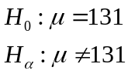
Test statistic: t = 1.563
p-value: 0.124
The sample mean is not significantly different from 131 at even the 10% level because the p-value is greater than 0.10

64. For which values of the sample mean (i.e., average weekly grocery bill) would you decide to reject the null hypothesis at the 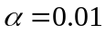 significance level? For which values of the sample mean would you decide to reject the null hypothesis at the 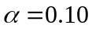 significance level?

ANSWER:
For either p-value (0.01 or 0.10), we find the t-value that would lead to the rejection of the null hypothesis, and then solve the equation 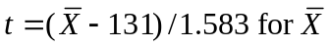on either side of 131. This leads to the following results:

-value | t-value | Lower limit | Upper limit
0.01 | 2.680 | 126.758 | 135.242
0.10 | 1.677 | 128.346 | 133.654

For example, at the 10% level, if 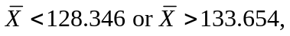we would reject the null hypothesis.

QUESTIONS 65 THROUGH 68 ARE BASED ON THE FOLLOWING INFORMATION:

Do undergraduate business students who major in information systems (IS) earn, on average, higher annual starting salaries than their peers who major in marketing (Mktg)? Before addressing this question with a statistical hypothesis test, a comparison should be done to determine whether the variances of annual starting salaries of the two types of majors are equal. Below you will find the StatPro output for 20 randomly selected IS majors and 20 randomly selected Mktg majors.

Summary statistics for two samples
 | IS Salary |  | Mktg Salary
Sample sizes | 20 |  | 20
Sample means | 30401.35 |  | 27715.85
Sample standard deviations | 1937.52 |  | 2983.39
Test of difference 0
Sample mean difference |  | 2685.5
Pooled standard deviation |  | 2515.41 |  | NA
Std error of difference |  | 795.44 |  | 795.44
Degrees of freedom |  | 38 |  | 33
t-test statistic |  | 3.376 |  | 3.376
p-value |  | 0.0009 |  | 0.0009
Test of equality of variances
Ratio of sample variances |  | 2.371
p-value |  | 0.034
65. Use the information above to perform the test of equal variance. Explain how the ratio of sample variances is calculated. What type of distribution is used to test for equal variances? Also, would you conclude that the variances are equal or not? Explain your answer.

ANSWER:
(2983.39)² / (1937.52)² = 2.371. Since the p-value is 0.034, you can conclude that there is a significant difference between the sample variance. They are not equal.

66. Based on your conclusion in Question 65, which test statistic should be used in performing a test for the existence of a difference between population means?

ANSWER:
Conduct the t-test with individual sample variances (do not use pooled variance).

67. Using a 5% level of significance, is there sufficient evidence to conclude that IS majors earn, on average, a higher annual starting salaries than their peers who major in Mktg? Explain your answer.

ANSWER:
Yes. The average starting salary for IS majors is significantly larger than the starting salary for MKT majors, since p-value = 0.0009 < 0.05.

68. Using a 1% level of significance, is there sufficient evidence to conclude that IS majors earn, on average, a higher annual starting salaries than their peers who major in Mktg? Explain your answer.

ANSWER:
Yes. The average starting salary for IS majors is significantly larger than the starting salary for MKT majors even at a 1% significance level, since p-value = 0.0009 < 0.01.

69. A recent study of educational levels of 1000 voters and their political party affiliations in a Midwestern state showed the results given in the table below. Use the 5% significance level and test to determine if party affiliation is independent of the educational level of the voters.

 |  | Party Affiliation
 |  | Democrat | Republican | Independent
 | Didn't Complete High School | 95 | 80 | 115 | 290
Educational Level | Has High School Diploma | 135 | 85 | 105 | 325
 | Has College Degree | 160 | 105 | 120 | 385
 |  | 390 | 270 | 340 | 1000

ANSWER:

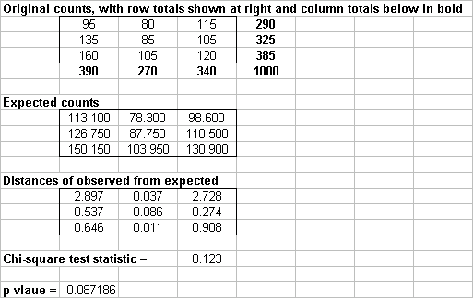
We fail to reject the null hypothesis of independence at the 5% significance level (since p-value = 0.087 > .05). We may conclude that party affiliation is independent of the educational level of the voters.

QUESTIONS 70 THROUGH 73 ARE BASED ON THE FOLLOWING INFORMATION:

A marketing research consultant hired by Coca-Cola is interested in determining if the proportion of customers who prefer Coke to other brands is over 50%. A random sample of 200 consumers was selected from the market under investigation, 55% favored Coca-Cola over other brands. Additional information is presented below.

Sample proportion | 0.55
Standard error of sample proportion | 0.03518
Z test statistic | 1.4213
p-value | 0.07761

70. If you were to conduct a hypothesis test to determine if greater than 50% of customers prefer Coca-Cola to other brands, would you conduct a one-tail or a two-tail hypothesis test? Explain your answer.

ANSWER:
One-tailed, since the consultant is interested in finding whether the proportion is actually greater than 50%.

71. How many customers out of the 200 sampled must have favored Coke in this case?

ANSWER:
(200)(0.55) = 110

72. Using a 5% significance level, can the marketing consultant conclude that the proportion of customers who prefer Coca-Cola exceeds 50%? Explain your answer.

ANSWER:
No. You cannot reject the null hypothesis at a 5% level of significance, since p-value = 0.07761 > 0.05.

73. If you were to use a 1% significance level, would the conclusion from part c change? Explain your answer.

ANSWER:
No. You still cannot reject the null hypothesis at a 1% level of significance, since p-value = 0.07761 > 0.01.

QUESTIONS 74 THROUGH 77 ARE BASED ON THE FOLLOWING INFORMATION:

The owner of a popular Internet-based auction site believes that more than half of the people who sell items on her site are women. To test this hypothesis, the owner sampled 1000 customers who sale items on her site and she found that 53% of the customers sampled were women. Some calculations are shown in the table below

Sample proportion | 0.53
Standard error of sample proportion | 0.01578
Z test statistic | 1.9008
p-value | 0.0287

74. If you were to conduct a hypothesis test to determine if greater than 50% of customers who use this Internet-based site are women, would you conduct a one-tail or a two-tail hypothesis test? Explain your answer.

ANSWER:
One-tailed, since the owner is interested in finding whether the proportion is actually greater than 50%.

75. How many customers out of the 1000 sampled must have been women in this case?

ANSWER:
(1000)(0.53) = 530

76. Using a 5% significance level, can the owner of this site conclude that women make up more than 50% of her customers? Explain your answer.

ANSWER:
Yes. You can reject the null hypothesis at a 5% level of significance, since p-value = 0.0287 < 0.05.

77. If you were to use a 1% significance level, would the conclusion from Question 76 change? Explain your answer.

ANSWER:
Yes. Your answer would now change. You cannot reject the null hypothesis at a 1% level of significance, since p-value = 0.0287 > 0.01.

QUESTIONS 78 THROUGH 82 ARE BASED ON THE FOLLOWING INFORMATION:

Q-Mart is interested in comparing customer who used it own charge card with those who use other types of credit cards. Q-Mart would like to know if customers who use the Q-Mart card spend more money per visit, on average, than customers who use some other type of credit card. They have collected information on a random sample of 38 charge customers and the data is presented below. On average, the person using a Q-Mart card spends $192.81 per visit and customers using another type of card spend $104.47 per visit.

Summary statistics for two samples
 | Q-Mart |  |  |  | Other Charges
Sample sizes | 13 |  |  |  | 25
Sample means | 192.81 |  |  |  | 104.47
Sample standard deviations | 115.243 |  |  |  | 71.139
Test of difference=0
Sample mean difference |  | 88.34
Pooled standard deviation |  | 88.323
Std error of difference |  | 30.201
t-test statistic |  | 2.925
p-value |  | 0.006

78. Given the information above, what is and for this comparison? Also, does this represent a one-tailed or a two-tailed test? Explain your answer.

ANSWER:
. This represents a one-tail test.

79. What are the degrees of freedom for the t-statistic in this calculation? Explain how you would calculate the degrees of freedom in this case.

ANSWER:
d.f = 13 + 25 – 2 = 36

80. What is the assumption in this case that allows you to use the pooled standard deviation for this confidence interval?

ANSWER:
The assumption is that the two populations standard deviations are equal; that is 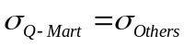

81. Using a 5% level of significance, is there sufficient evidence for Q-Mart to conclude that customers who use the Q-Mart card charge, on average, more than those who use another charge card? Explain your answer.

ANSWER:
Yes. There is a statistical difference between those using the Q-Mart card and those who use other types of charge cards, since p-value = 0.006 < 0.05.

82. Using a 1% level of significance, is there sufficient evidence for Q-Mart to conclude that customers who use the Q-Mart card charge, on average, more than those who use another charge card? Explain your answer.

ANSWER:
Yes. There is still a statistical difference between those using the Q-Mart card and those who use other types of charge cards, since p-value = 0.006 < 0.01.

83. The number of cars sold by three salespersons over a 6-month period are shown in the table below. Use the 5% level of significance to test for independence of salespersons and type of car sold.

 |  | Insurance Preference
 |  | Chevrolet | Ford | Toyota
 | Ali | 15 | 9 | 5 | 29
Salesperson | Bill | 20 | 8 | 15 | 43
 | Chad | 13 | 4 | 11 | 28
 |  | 48 | 21 | 31 | 100

ANSWER:
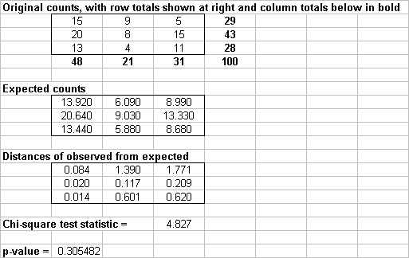

We fail to reject the null hypothesis of independence at the 5% significance level (since p-value = 0.305 > 0.05). We may conclude that salespersons and type of car sold are independent.

QUESTIONS 84 AND 85 ARE BASED ON THE FOLLOWING INFORMATION:

An automobile manufacturer needs to buy aluminum sheets with an average thickness of 0.05 inch. The manufacturer collects a random sample of 40 sheets from a potential supplier. The thickness of each sheet in this sample is measured (in inches) and recorded. The information below are pertaining to the Chi-square goodness-of-fit test.

Upper limit | Category |  | Frequency | Normal | Distance measure
0.03 | 0.03 |  | 1 | 1.920 | 0.441
0.04 | 0.03 but 0.04 |  | 10 | 8.074 | 0.459
0.05 | 0.04 but 0.05 |  | 13 | 14.947 | 0.254
0.06 | 0.05 but 0.06 |  | 12 | 11.218 | 0.055
 | >0.06 |  | 4 | 3.842 | 0.007
Test of normal fit
Chi-square statistic |  | 1.214
p-value |  | 0.545

84. Are these measurements normally distributed? Summarize your results.

ANSWER:
Yes. Based on the Chi-square test, with a p-value of 0.545, you can conclude that the values are normally distributed. The frequency distribution also shows that the values are fairly close to the expected values.

85. Are there any weaknesses or concerns about your conclusions in Question 84? Explain your answer.

ANSWER:
Yes. There are a couple of concerns. The sample size is rather small (n = 40), you should use a larger sample size for this test to be more effective. Also, the test depends on which and how many categories are used for the histogram. A different choice could result in a different answer.

QUESTIONS 86 THROUGH 88 ARE BASED ON THE FOLLOWING INFORMATION:

Do undergraduate business students who major is computer information systems (CIS) earn, on average, higher annual starting salaries than their peers who major in international business (IB)?. To address this question through a statistical hypothesis test, the table shown below contains the starting salaries of 25 randomly selected CIS majors and 25 randomly selected IB majors.
Graduate | Finance | Marketing
1 | 29,522 | 28,201
2 | 31,444 | 29,009
3 | 29,275 | 29,604
4 | 26,803 | 26,661
5 | 28,727 | 26,094
6 | 32,531 | 22,900
7 | 33,373 | 24,939
8 | 31,755 | 23,071
9 | 31,393 | 29,852
10 | 26,124 | 27,213
11 | 30,653 | 23,935
12 | 30,795 | 25,794
13 | 30,319 | 28,897
14 | 31,654 | 27,890
15 | 27,214 | 27,400
16 | 30,579 | 26,818
17 | 30,249 | 27,603
18 | 31,024 | 26,880
19 | 31,940 | 28,791
20 | 31,387 | 24,000
21 | 29,479 | 25,877
22 | 30,735 | 24,825
23 | 29,271 | 28,423
24 | 30,215 | 28,956
25 | 31,587 | 29,758

86. Is it appropriate to perform a paired-comparison t-test in this case? Explain why or why not.

ANSWER:
A two-sample, not paired-sample, procedure should be used because there is no evidence of pairing.

87. Perform an appropriate hypothesis test with a 1% significance level. Assume that the population variances are equal.

ANSWER:
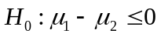, 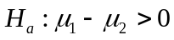, Test statistic t = 6.22, P-value=0. Since P-value is virtually 0, we can conclude at the 1% level that the mean salary for CIS majors is indeed larger.

88. How large would the difference between the mean starting salaries of CIS and IB majors have to be before you could conclude that CIS majors earn more on average? Employ a 1% significance level in answering this question.

ANSWER:
P-value=0.01, t =2.41, and Standard error of difference = 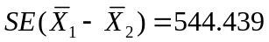. Then 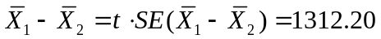
A mean difference of 1312.20 is all that would be required to get the conclusion in Question 87 at the 1% level.

89. A statistics professor has just given a final examination in his linear models course. He is particularly interested in determining whether the distribution of 50 exam scores is normally distributed. The data are shown in the table below. Perform the Lilliefors test. Report and interpret the results of the test.

77 71 78 83 84 71 81 82 79 71
73 89 74 75 93 74 88 83 90 82
79 62 73 88 76 76 76 80 84 84
91 70 76 74 68 80 87 92 84 79
80 91 74 69 88 84 83 87 82 72

ANSWER:
The maximum distance between the empirical and normal cumulative distributions is 0.0802. This is less than 0.1247, the maximum allowed with a sample size of 50. Therefore, the normal hypothesis cannot be rejected at the 5% level.

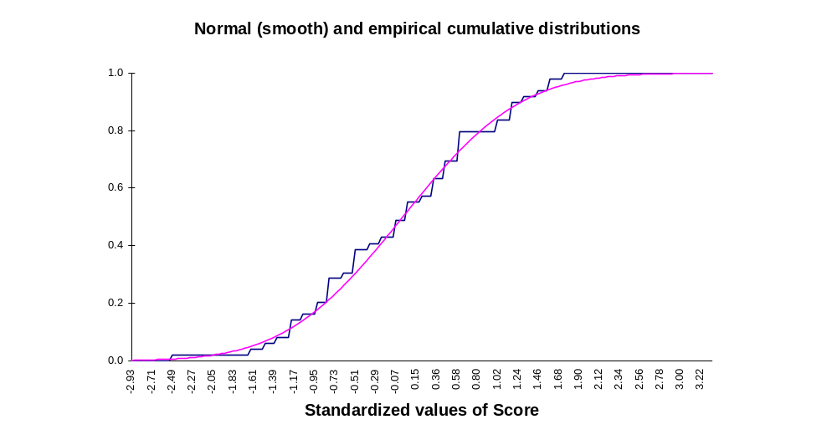

90. An insurance firm interviewed a random sample of 600 college students to find out the type of life insurance preferred, if any. The results are shown in the table below. Is there evidence that life insurance preference of male students is different than that of female students. Test at the 5% significance level.

 |  | Insurance Preference
 |  | Term | Whole Life | No Insurance
 | Male | 80 | 30 | 240 | 350

Gender
 | Female | 50 | 40 | 160 | 250
 |  | 130 | 70 | 400 | 600

ANSWER:
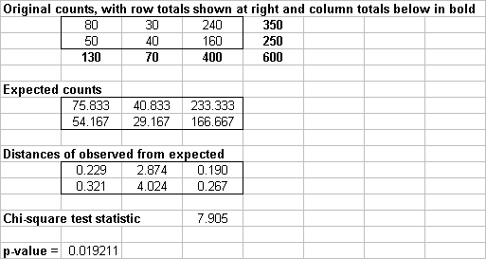

We reject the null hypothesis of independence at the 5% significance level (since p-value = 0.019 < 0.05). We may conclude that there is no evidence that life insurance preference of male students is different than that of female students.

QUESTIONS 91 THROUGH 93 ARE BASED ON THE FOLLOWING INFORMATION:

The retailing manager of Meijer supermarket chain in Michigan wants to determine whether product location has any effect on the sale of children toys. Three different aisle locations are considered: front, middle, and rear. A random sample of 18 stores is selected, with 6 stores randomly assigned to each aisle location. The size of the display area and price of the product are constant for all the stores. At the end of one-month trial period, the sales volumes (in thousands of dollars) of the product in each store were as shown below:

Front Aisle | Middle Aisle | Rear Aisle
10.0 | 4.6 | 6.0
8.6 | 3.8 | 7.4
6.8 | 3.4 | 5.4
7.6 | 2.8 | 4.2
6.4 | 3.2 | 3.6
5.4 | 3.0 | 4.2

91. At the 0.05 level of significance, is there evidence of a significant difference in average sales among the various aisle locations?

ASNWER:
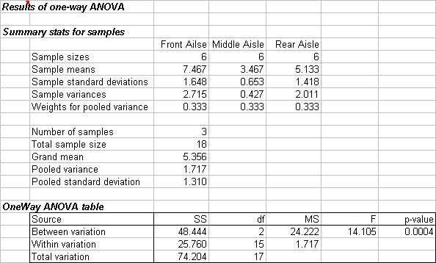
StatPro’s one-way ANOVA produces the following results:

To test at the 0.05 level of significance whether the average sales volumes in thousands of dollars are different across the three store aisle locations, we conduct an F test:
H₀: 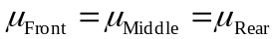
H₁: At least one mean is different.

Since p-value = 0.0004 < = 0.05, we reject H₀. There is enough evidence to conclude that the average sales volumes in thousands of dollars are different across the three store aisle locations.

92. If appropriate, which aisle locations appear to differ significantly in average sales? (Use = 0.05)

ANSWER:
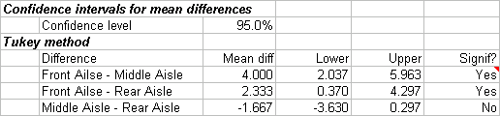
It appears that the front and middle aisles and also the front and rear aisles differ significantly in average sales at = 0.05.

93. What should the retailing manager conclude? Fully describe the retailing manager’s options with respect to aisle locations?

ANSWER:
The front aisle is best for the sale of this product. The manager should evaluate the tradeoff in switching the location of this product and the product that is currently intended for the front location.

QUESTIONS 94THROUGH 97 ARE BASED ON THE FOLLOWING INFORMATION:

A real estate agency wants to compare the appraised values of single-family homes in two cities in Michigan. A sample of 60 listings in Lansing and 99 listings in Grand Rapids yields the following results (in thousands of dollars):

 | Lansing | Big Rapids
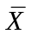 | 191.33 | 172.34
S | 32.60 | 16.92
n | 60 | 99

94. Is there evidence of a significant difference in the average appraised values for single-family homes in the two Michigan cities? Use 0.05 level of significance.

ANSWER:
Populations: 1 = Lansing, 2 = Grand Rapids

H₀: 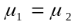 (The average appraised values for single-family homes are the same
in Lansing and Grand Rapids)
H₁: 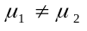 (The average appraised values for single-family homes are not the
same in Lansing and Grand Rapids)

Decision rule: df = 157. If t < – 1.9752 or t > 1.9752, reject H₀.

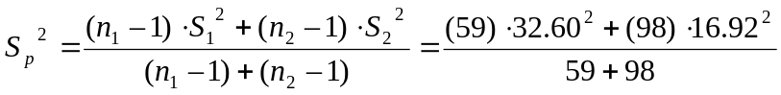= 578.0822
Test statistic:

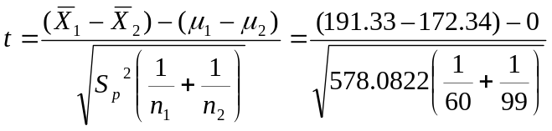= 4.8275

Decision: Since t_{calc} = 4.8275 is above the upper critical bound of 1.9752, reject H₀. There is enough evidence to conclude that there is a difference in the average appraised values for single-family homes in the two Michigan cities. The p value is 3.25E-06 using Excel.

95. Do you think any of the assumptions needed in Question 94 have been violated? Explain.

ANSWER:
The assumption of equal variances may be violated because the sample variance in Lansing is nearly four times the size of the sample variance in Grand Rapids and the two sample sizes are not small. Nevertheless, the results of the test for the differences in the two means were overwhelming (i.e., the p value is nearly 0).

96. Construct a 95% confidence interval estimate of the difference between the population means of Lansing and Grand Rapids.

ANSWER:
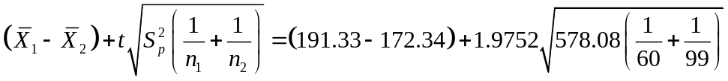

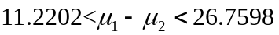

97. Explain how to use the confidence interval in Question 96 to answer Question 94.

ANSWER:
Since the 95% confidence interval in Question 96 does not include 0, we reject the null hypothesis at the 5% level of significance that the average appraised values for single-family homes are the same in Lansing and Grand Rapids.

QUESTIONS 98THROUGH 100 ARE BASED ON THE FOLLOWING INFORMATION:

In a survey of 1,500 customers who did holiday shopping on line during the 2000 holiday season, 270 indicated that they were not satisfied with their experience. Of the customers that were not satisfied, 143 indicated that they did not receive the products in time for the holidays, while 1,197 of the customers that were satisfied with their experience indicated that they did receive the products in time for the holidays. The following complete summary of results were reported:

Received Products in Time
for Holidays

Satisfied with their Experience | Yes | No | Total
Yes | 1,197 | 33 | 1,230
No | 127 | 143 | 270
Total | 1,324 | 176 | 1,500

98. Is there a significant difference in satisfaction between those who received their products in time for the holidays, and those who did not receive their products in time for the holidays? Test at the 0.01 level of significance.

ANSWER:
Populations: 1 = received product in time, 2 = did not receive product in time

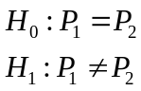

Decision rule: If Z < -2.5758 or Z > 2.5758, reject H₀.
Test statistic: 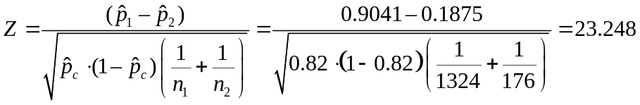

Decision: Since Z_{calc} = 23.248 is well above the upper critical bound of Z = 2.5758, reject H₀. There is sufficient evidence to conclude that a significant difference in satisfaction exists between those who received their products in time for the holidays and those who did not receive their products in time for the holidays.

99. Find the p-value in Question 98 and interpret its meaning.

ANSWER:
The p-value is virtually 0. The probability of obtaining a difference in two sample proportions as large as 0.7166 or more is virtually 0 when is true.

100. Based on the results of Questions 98 and 99, if you were the marketing director of a company selling products online, what would you do to improve the satisfaction of the customers?

ANSWER:
Ensuring that the customers receive their products in time for the holidays will be one effective way to improve the satisfaction of the customers.

TRUE / FALSE QUESTIONS

101. The p-value of a test is the probability of observing a test statistic at least as extreme as the one computed given that the null hypothesis is true.

ANSWER: T

102. The p-value is usually 0.01 0r 0.05.

ANSWER: F

103. A null hypothesis is a statement about the value of a population parameter. It is usually the current thinking, or “status quo”.

ANSWER: T

104. An alternative or research hypothesis is usually the hypothesis a researcher wants to prove.

ANSWER: T

105. A two-tailed alternative is one that is supported by evidence in a single direction.

ANSWER: F

106. A one-tailed alternative is one that is supported by evidence in either direction.

ANSWER: F

107. A Type I error probability is represented by ; it is the probability of incorrectly rejecting a null hypothesis that is true.

ANSWER: T

108. A Type II error is committed when we incorrectly accept an alternative hypothesis that is false.

ANSWER: F

109. The probability of making a Type I error and the level of significance are the same.

ANSWER: T

110. The p-value of a test is the smallest level of significance at which the null hypothesis can be rejected.

ANSWER: T

111. If a null hypothesis about a population mean is rejected at the 0.025 level of significance, it must be rejected at the 0.01 level.

ANSWER: F

112. In order to determine the p-value, it is unnecessary to know the level of significance.

ANSWER: T

113. If we reject a null hypothesis about a population proportion p at the 0.025 level of significance, then we must also reject it at the 0.05 level.

ANSWER: T

114. Using the confidence interval when conducting a two-tailed test for the population mean, we do not reject the null hypothesis if the hypothesized value for falls between the lower and upper confidence limits.

ANSWER: T

115. A professor of statistics refutes the claim that the proportion of independent voters in Minnesota is at most 40%. To test the claim, the hypotheses: 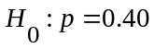, 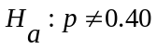, should be used.

ANSWER: F

116. Using the confidence interval when conducting a two-tailed test for the population proportion p, we reject the null hypothesis if the hypothesized value for p falls inside the confidence interval.

ANSWER: F

117. When testing the equality of two population variances, the test statistic is the ratio of the population variances; namely 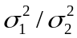.

ANSWER: F

118. Tests in which samples are not independent are referred to as matched pairs.

ANSWER: T

119. The pooled-variances t-test requires that the two population variances are different.

ANSWER: F.

120. In testing the difference between two population means using two independent samples, we use the pooled variance in estimating the standard error of the sampling distribution of the sample mean difference 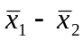 if the populations are normal with equal variances.

ANSWER: T

121. In conducting hypothesis testing for difference between two means when samples are dependent, the variable under consideration is 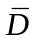; the sample mean difference between n pairs.

ANSWER: T

122. The number of degrees of freedom associated with the t test, when the data are gathered from a matched pairs experiment with 12 pairs, is 22.

ANSWER: F

123. The test statistic employed to test 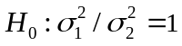 is 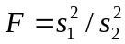, which is F distributed with 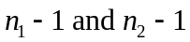degrees of freedom.

ANSWER: T

124. When the necessary conditions are met, a two-tail test is being conducted to test the difference between two population proportions. The two sample proportions are 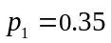 and 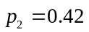, and the standard error of the sampling distribution of 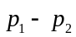is 0.054. The calculated value of the test statistic will be 1.2963.

ANSWER: F

125. The equal-variances test statistic of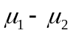 is Student t distributed with 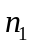+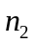-2 degrees of freedom, provided that the two populations are normally distributed.

ANSWER: T

126. When the necessary conditions are met, a two-tail test is being conducted at = 0.05 to test. The two sample variances are 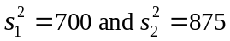, and the sample sizes are 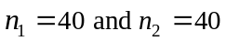. The calculated value of the test statistic will be F = 0.80.

ANSWER: T

127. Statistics practitioners use the analysis of variance (ANOVA) technique to compare more than two population means.

ANSWER: T

128. Given the significance level 0.01, the F-value for the degrees of freedom, d.f. = (6,9) is 7.98.

ANSWER: F

129. The analysis of variance (ANOVA) technique analyzes the variance of the data to determine whether differences exist between the population means.

ANSWER: T

130. The F-test of the analysis of variance requires that the populations be normally distributed with equal variances.

ANSWER: T

131. One-way ANOVA is applied to four independent samples having means 13, 15, 18 and 20, respectively. If each observation in the forth sample were increased by 30, the value of the F-statistics would increase by 30.

ANSWER: F

132. The degrees of freedom for the denominator of a one-way ANOVA test for 4 population means with 10 observations sampled from each population are 40.

ANSWER: F

133. A test for independence is applied to a contingency table with 4 rows and 4 columns. The degrees of freedom for this chi-square test must equal 9.

ANSWER: T

134. The number of degrees of freedom for a contingency table with r rows and c columns is rc - 1 , provided that both r and c are greater than or equal to 2.

ANSWER: F

135. The Lilliefors test is used to test for normality.

ANSWER: T

